Franklin Colton Parry

CS 2600 Lab 5

11/11/2013

Question 1, solution part A

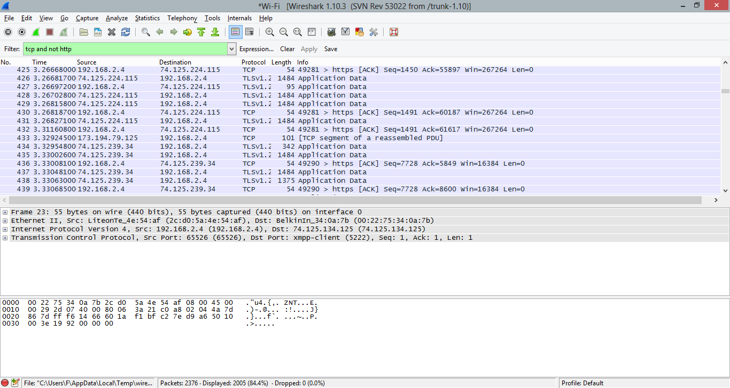

Question 1 part b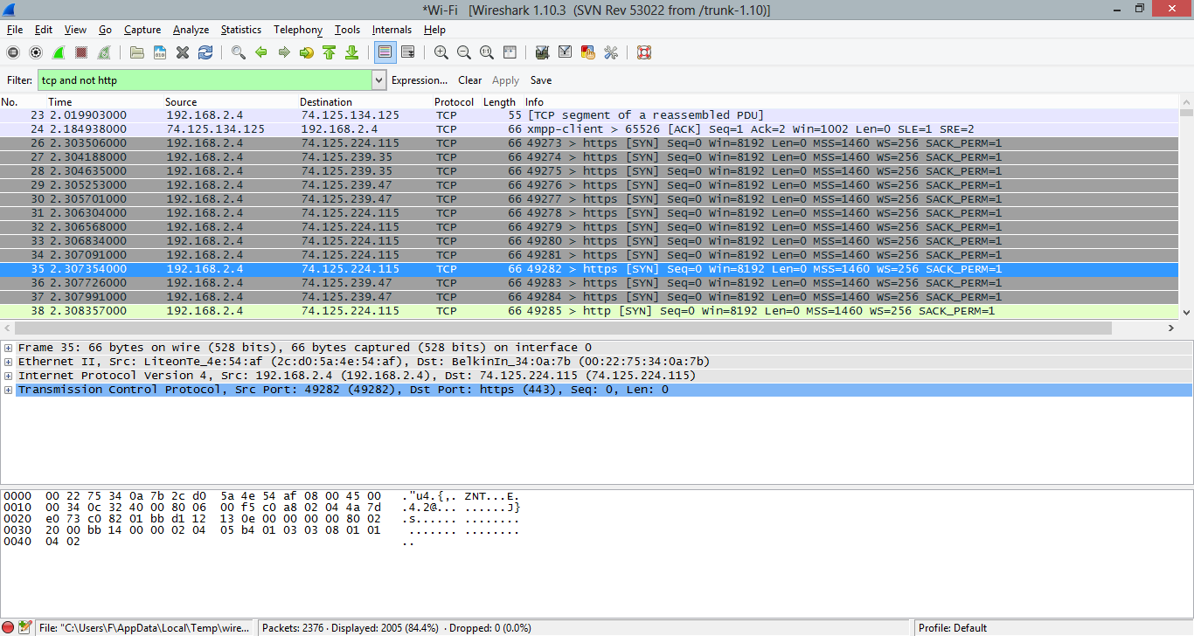

Question 2 Solution

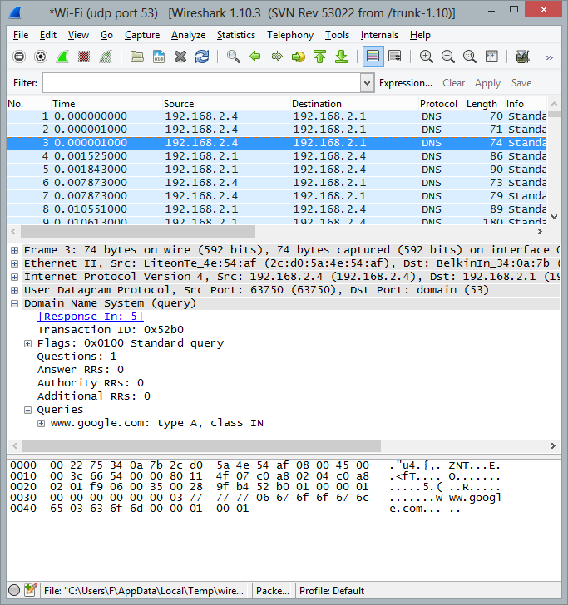

Question 3 Solution

